SIMATS ENGIN EERING
SAVEETHA INSTITUTE OF MEDICAL AND TECHNICAL SCIENCES

EXPERIMENT 04
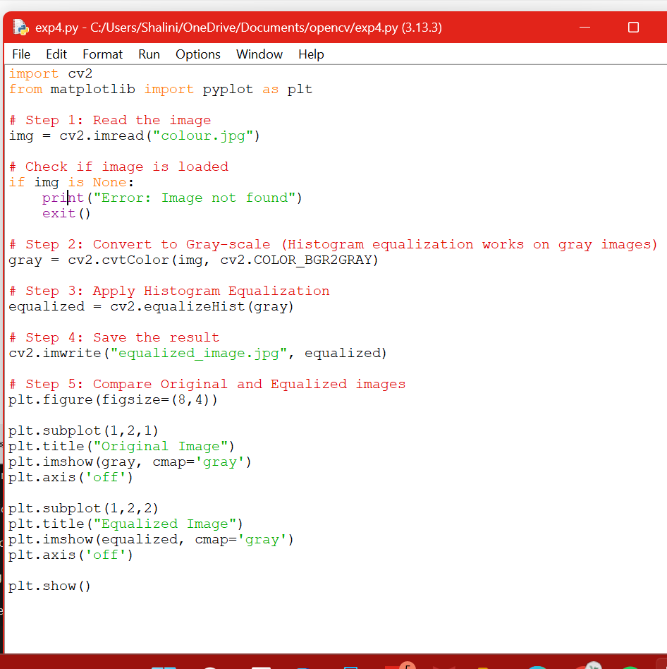
OUTPUT:
